Linkedin

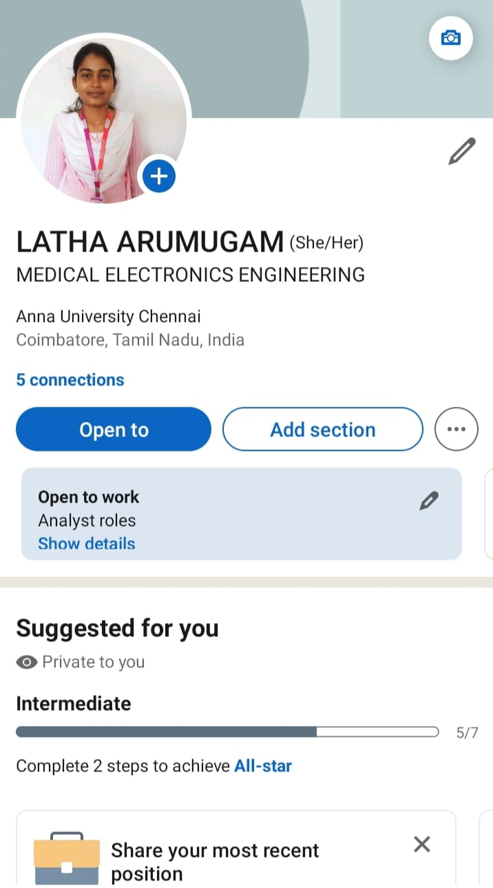k<https://www.linkedin.com/in/latha-arumugam>

[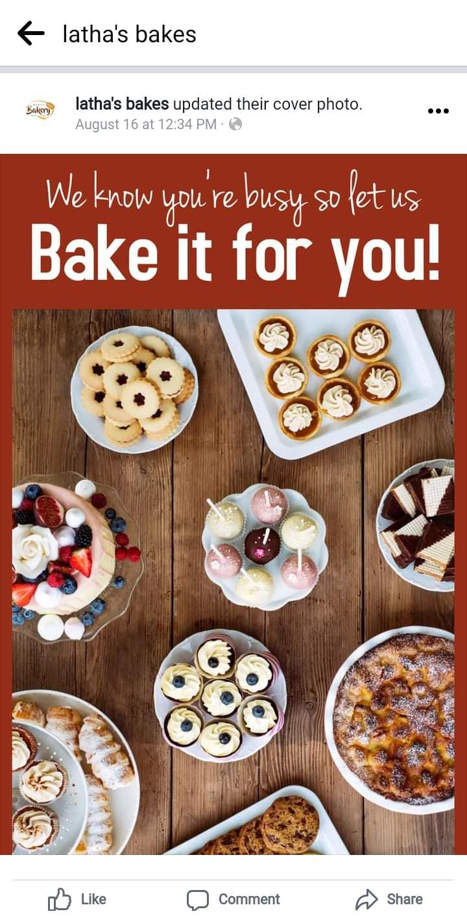](https://www.facebook.com/profile.php?id=61550099705070&mibextid=ZbWKwL)https://www.facebook.com/profile.php?id=61550099705070&mibextid=ZbWKwL

Facebook Ad

Email newsletter

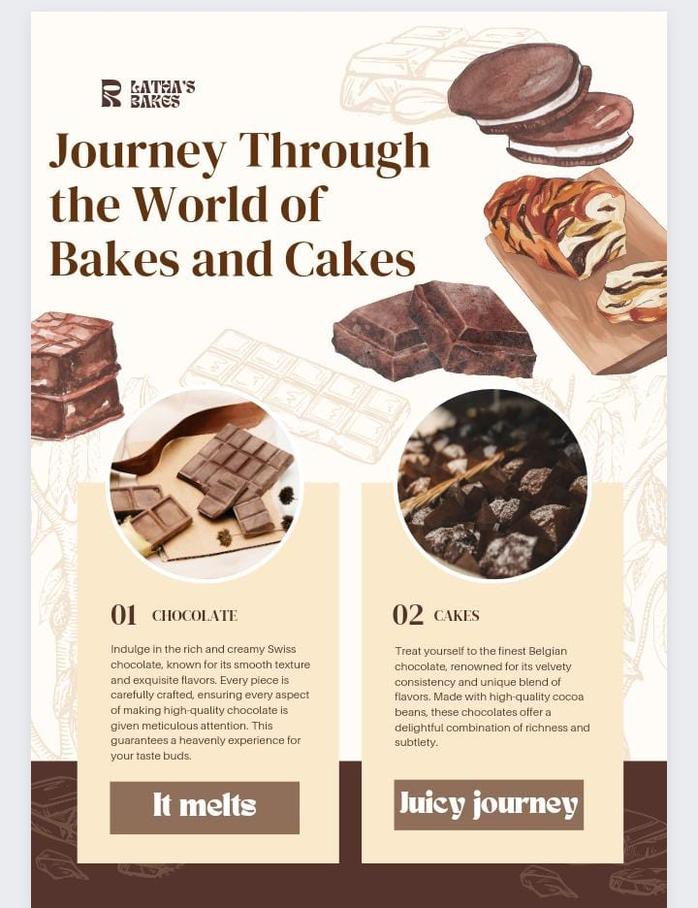https://www.canva.com/design/DAFw8uSBzKk/qrSxqTVfGKrD6v_7DZ_qEQ/edit?utm_content=DAFw8uSBzKk&utm_campaign=designshare&utm_medium=link2&utm_source=sharebutton

[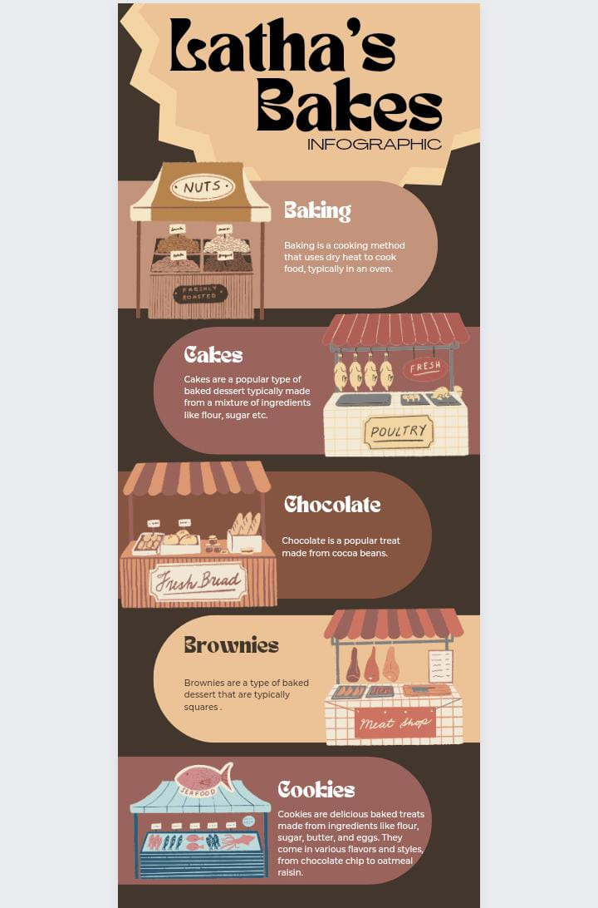](https://www.canva.com/design/DAFxmmxR2PE/u7WpmdtuI63d2xObFfXU2w/edit?utm_content=DAFxmmxR2PE&utm_campaign=designshare&utm_medium=link2&utm_source=sharebutton)https://www.canva.com/design/DAFxmmxR2PE/u7WpmdtuI63d2xObFfXU2w/edit?utm_content=DAFxmmxR2PE&utm_campaign=designshare&utm_medium=link2&utm_source=sharebutton

Infography

[[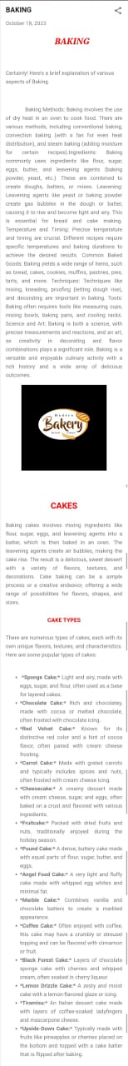](https://lathabakes.blogspot.com/2023/10/baking.html)](https://lathabakes.blogspot.com/2023/10/baking.html)https://lathabakes.blogspot.com/2023/10/baking.html

Blog

Google Analytics

[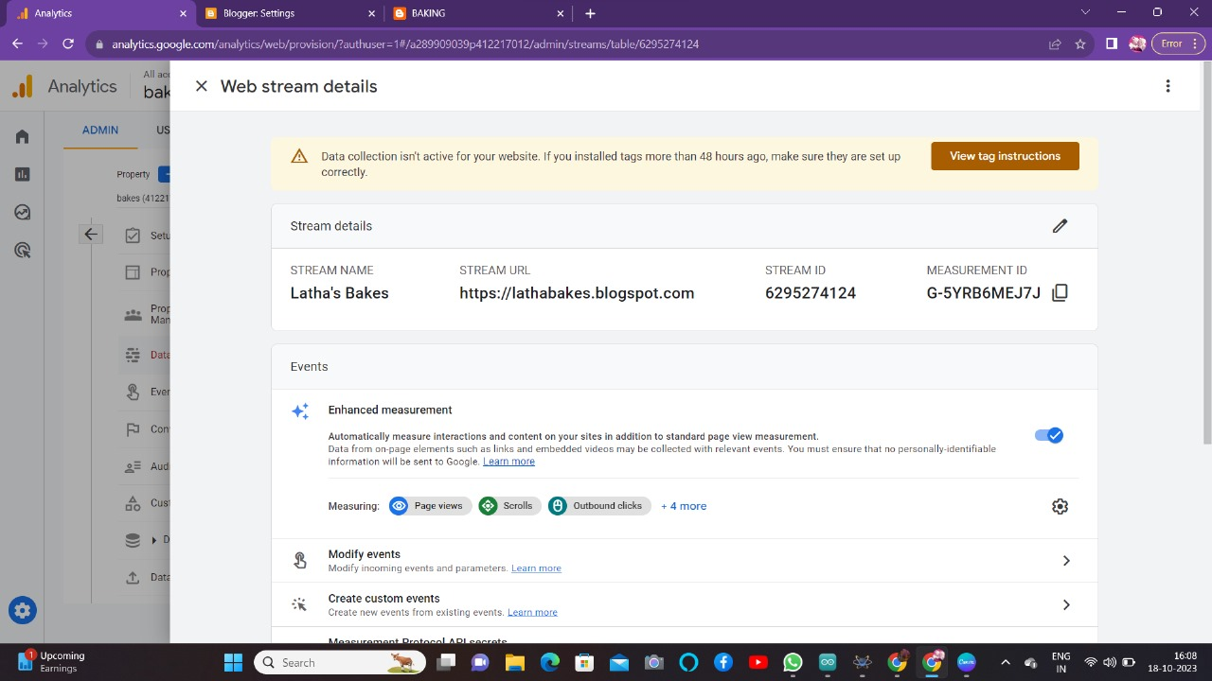](http://G-5YRB6MEJ7J/)http://G-5YRB6MEJ7J/